The Therapeutic Relationship

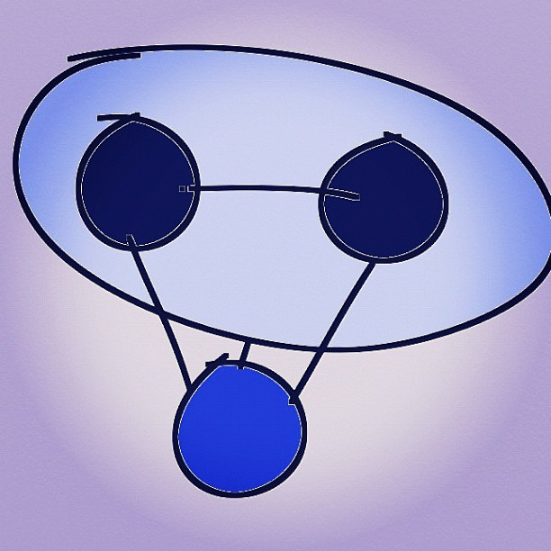

## The relationship with the relationship

The first step towards encounter is creating a holding environment. The couple can learn to do this for themselves, however initially the therapist will be pro-active to make this happen, and the therapist forms a relationship with each partner and the relationship itself. Establishing the purpose of the work and making an assessment of the role dynamics is ongoing.

**Three questions:**

1. What would the relationship look like if it were working well?   
   (Later in the work this question becomes: How would you know the therapy is complete?)
2. What have you done to prevent this from happening? (You, not the other partner)
3. What do you imagine you could do differently?

**Assessment & Purpose**

A statement about the role dynamics:

Example:

You feel stressed and you think your stress is unfair and you blame. To the other party: You respond to blame by spending more time biking. The more you both do this the more you do it. It’s a vicious circle.

A statement by the therapist of the state of the relationship – using metaphor and the purpose of the therapy is useful to bring together the warm up and focus the work:

Example:

You are here to rekindle this relationship. If it were a fire it is almost out and you want to build it up. You are here to learn how to do that, and turn that vicious circle around.

## Invitation to Encounter

You can get this relationship back on track, and build your love and romance by really seeing and hearing each other. I can teach you ways to do that here with me and you will be able to do this at home as well. One main way is a conscious dialogue process I will teach you. Are you willing to give that a go?

## Role of the Therapist with Couples

There is a continuum with two extremes.

|  |  |  |
| --- | --- | --- |
| Its all in the dialogue between the couple | ____________________________________ | Its all in the safety of the relationship with the therapist |

Of course it is both, I doubt anyone holds the extreme positions. However it is an interesting question as to when one of these aspects needs to be to the fore.

This discussion with Rick & Sherry Stolp addresses this question very well, among other things.

lick to play & download[Listen or download here](http://www.psyberspace.walterlogeman.com/audio/2010/Stolp9-16-09.mp3)

<http://www.psyberspace.walterlogeman.com/audio/2010/Stolp9-16-09.mp3>

[Rick Stolp website](http://www.rickstolp.com/)

<http://www.rickstolp.com/>